W/C 15.06.20 Learning Project - Famous & Significant People Online
Age Range: EYFS
Weekly Reading Tasks | Weekly Phonics Tasks
Monday- Ask your child to think about their favourite books and read one of them together. Find out about the famous authors and encourage your child to think about why they like these books? Information about Julia Donaldson is included at the end of the pack.  Practise reading and spelling the high frequency words attached below. Also continue to practise tricky words. | Monday- Sound Sprint - Make some sound cards (you could use paper). Place and spread them out across the floor. Ask your child to run and stand on the sound you call out.  Daily phonics - Please see the link already sent in Tapestry to the daily Ruth Miskin RWI sessions on youtube.
Tuesday- Read stories written by the famous author, Julia Donaldson. You can also listen to them if you click on the following links: Room on the Broom / Gruffalo.  Practise reading and spelling the high frequency words attached below. Also continue to practise tricky words. | Tuesday- Play Online Buried Treasure - Click on the sounds your child is learning. CHALLENGE: If you think it is a real word can you explain what the word means?  Daily phonics - Please see the link already sent in Tapestry to the daily Ruth Miskin RWI sessions on youtube.
Wednesday- Ask your child to draw pictures showing what happened at the beginning, middle and the end of Room on the Broom or The Gruffalo. Or choose a different story.  Practise reading and spelling the high frequency words attached below. Also continue to practise tricky words. | Wednesday- Ask your child to use their phonic knowledge to spell some of the names of the characters from the ‘The Gruffalo’? E.g. f-o-x, ow-l. If this is too tricky, can they say the sounds that make up the words instead?  Daily phonics - Please see the link already sent in Tapestry to the daily Ruth Miskin RWI sessions on youtube.
Thursday- Ask your child questions about the books that you have shared- Who are the main characters? How are the characters feeling? Who is your favourite character? Why? What did you like/dislike about this story?  Practise reading and spelling the high frequency words attached below. Also continue to practise tricky words. | Thursday- Play Viking Full Circle - Click on the set of sounds your child is learning. Listen carefully to the word and have a go at choosing the correct letters to make the word.  Daily phonics - Please see the link already sent in Tapestry to the daily Ruth Miskin RWI sessions on youtube.
Friday- Your child can choose a story to share with you from the free eBook library at Oxford Owl.  Practise reading and spelling the high frequency words attached below. Also continue to practise tricky words. | Friday- Choose a letter of the alphabet. How many famous people or book characters can your child think of that start with this letter?  Daily phonics - Please see the link already sent in Tapestry to the daily Ruth Miskin RWI sessions on youtube.
Weekly Writing Tasks | Weekly Maths Tasks- Adding
Monday- Watch ‘The Gruffalo’ here. Ask your child to draw a picture of their favourite character. Can they write words/sentences to describe their character, i.e. furry body, knobbly knees and black teeth. | Monday- Monday- Ask your child to counting on from any given number to 10 or 20 – e.g. 1,2,?,?,? or 3,4,?,? or 5,6,?,? etc  Comparing numbers to 10 - Make some skittles using plastic bottles with water/ sand or soil in them.  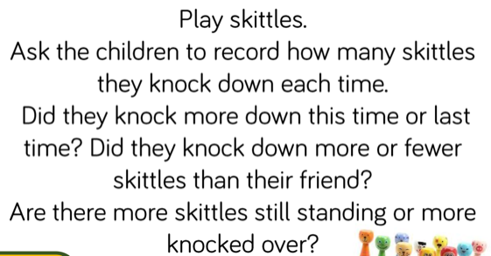
Tuesday- Can your child make a wanted poster for the Gruffalo. Can they draw a picture of the Gruffalo? Can they describe him?  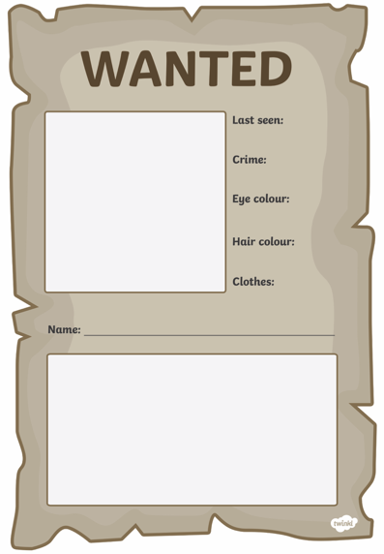 | Tuesday- - Number and place value to 10.  Provide your child with dot plates or cards with numbers 0 to 5  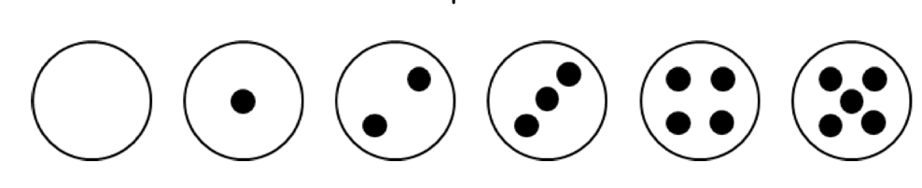  Ask your child to arrange the 6 plates onto the part whole models so that they have  a pair of plates with a total of 4 dots, a pair of plates with a total of 5 dots and a pair of plates with a total of 6 dots.  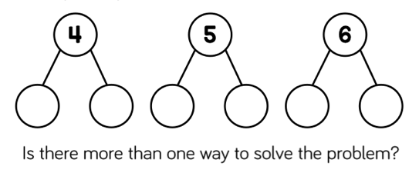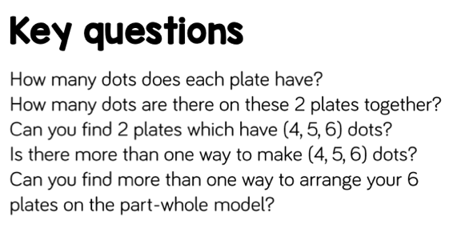
Wednesday- Practise writing the following letters, can you write them onto a line? g,r,u,f,f,a,l,o Take care with the letter ‘f’ and ‘g’ make sure the ‘tail’ comes below the line.  Practise writing your full name, can you form all the letters correctly?  Can you write the key words from this week forming all the letters  Correctly?  Pretend you have forgotten how to write the letters for Gruffalo. Ask your child to teach you how to write them. Children love playing teachers! | Wednesday- Adding numbers: Watch Numberblocks (clip 1) to support with adding. You can also click on clip 2 or clip 3.  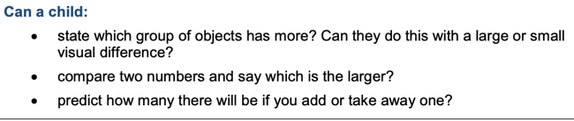  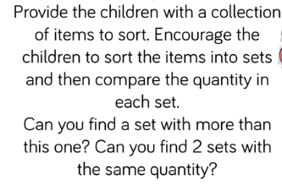
Thursday- Ask your child to think about who they believe to be important people – such as the Queen. How would your child describe them? Why do they think they are important? Your child could list important people. | Thursday- Generate your own addition number stories: First, there are 3 people on the bus. Then, 2 more people get on the bus. How many people are on the bus? Now there are 5 people on the bus.  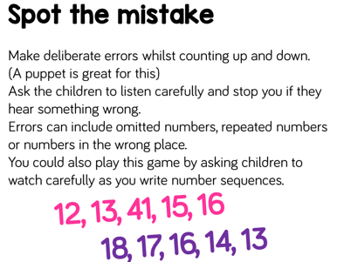
Friday- Ask your child to think about and draw someone who is very important to them. Can your child say or write a simple sentence describing why this person is so important. | 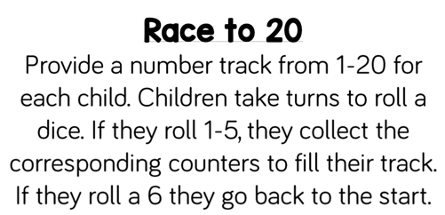  Friday  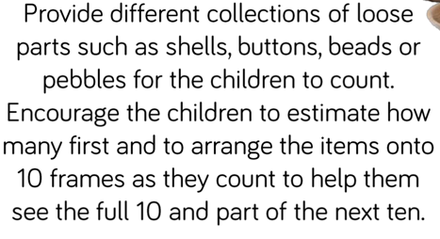  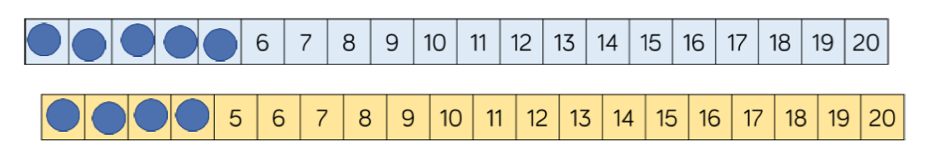

Learning Project - to be done throughout the week
The project this week aims to provide opportunities for your child to learn more about famous or significant people. Learning may focus on past or present inventors, explorers or scientists and how they influence society today.

Make your Favourite Characters-
- Make a puppet of a famous story character. Use a toilet roll and draw, colour and stick other bits of material onto the tube to make your own character puppet. This can be a character from the Gruffalo or a character from another story written by a different famous author.
- Paint your hand and make handprints and decorate to make your very own Gruffalo.

Can you Name the Famous Characters?
- Take part in the quiz -Who Do You Know? You will need help from your grown - ups. Have a go at Quiz 1 and Quiz 2. Or, you could also describe famous book characters to your child and they have to guess who it is you’re describing.

Play Snake
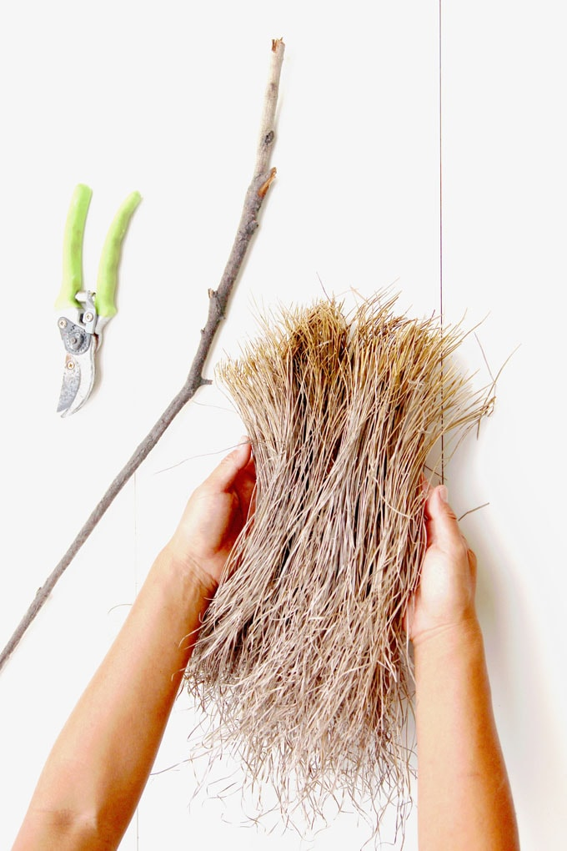
- The Gruffalo features a snake. Click here to play snake - Use the arrows on the keyboard to move the snake around - count how many apples you can collect. Or, play a family game of Snakes and Ladders.

Create your own Broomstick
- Create your own broomstick like the witch in ‘Room on the Broom’. You could gather up sticks from the garden and tie them on to the end of a large stick using elastic bands, string or garden twine. How could you make improvements to your broom? Encourage your child to act out the story. Take a photograph of your finished broomstick and upload to Twitter at #TheLearningProject.

Visit ‘The Gruffalo’ website
- Listen to the Gruffalo song, learn the ‘Monkey Puzzle’ song in makaton and dance along to the ‘Gruffalo’s Child’ song. There are also some great interactive games in the play and explore area. Colour your own Gruffalo using the paint game, create your own monster on monster maker and much more.

Mindfulness
- Help your child find a quiet space where they can sit comfortably. Encourage them to close their eyes, reminding them they are safe; this is their special mindfulness time which helps to keep their brain and body healthy.
- Ask your child to think of a famous person they admire (it could be a superhero or a family member if that is easier) and ask them to think about what they admire / like about that person. Are they strong? Are they kind?
- Help your child to turn this into positive affirmation such as ‘I am strong’, ‘I am kind’, or ‘I am helpful’. Explain to your child they can say these words inside their head every time they take a breath in. Every time they breathe out, they can relax their body a little bit more.
- Keep breathing and saying the words silently for a minute or so.
STEM Learning Opportunities #sciencefromhome
Rose Mitchtom and Margarette Steife
- Over 120 years ago two women came up with the idea to make a teddy bear. Collect all your teddy bears. Are they all the same? What do you think makes a good teddy bear? If you were going to invent a new teddy bear what would it look like?
Additional learning resources parents may wish to engage with
White Rose Maths online maths lessons. Watch a lesson video and complete the worksheet (can be downloaded and completed digitally).
Numbots. Your child can access this programme with their school login.
IXL Click on Maths, Reception. There are interactive games to play and guides for parents.
Talk for Writing Home-school Booklets are an excellent resource to support your child’s speaking and listening, reading and writing skills.
#TheLearningProjects
in collaboration with
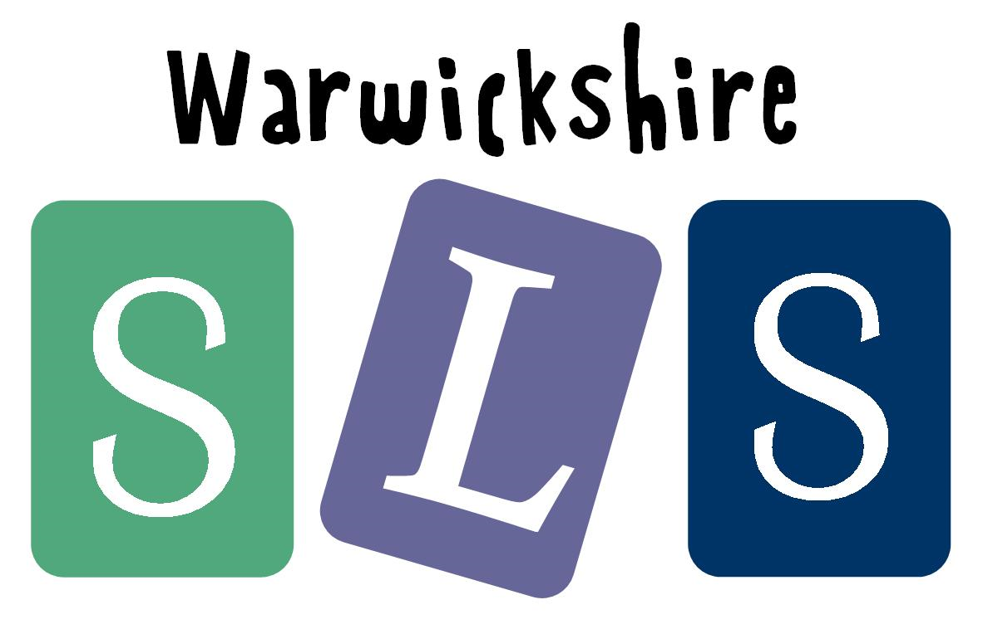
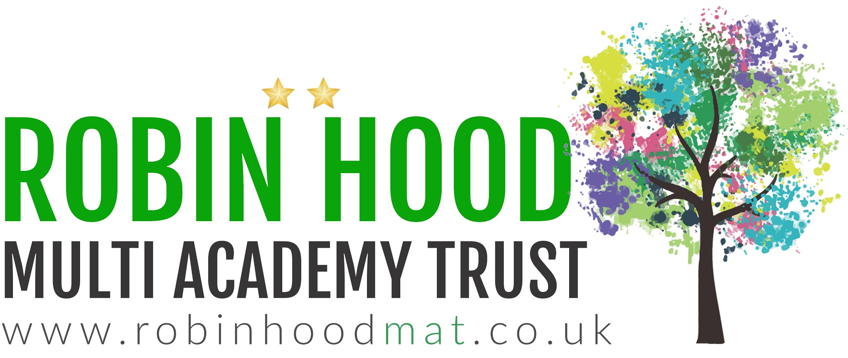
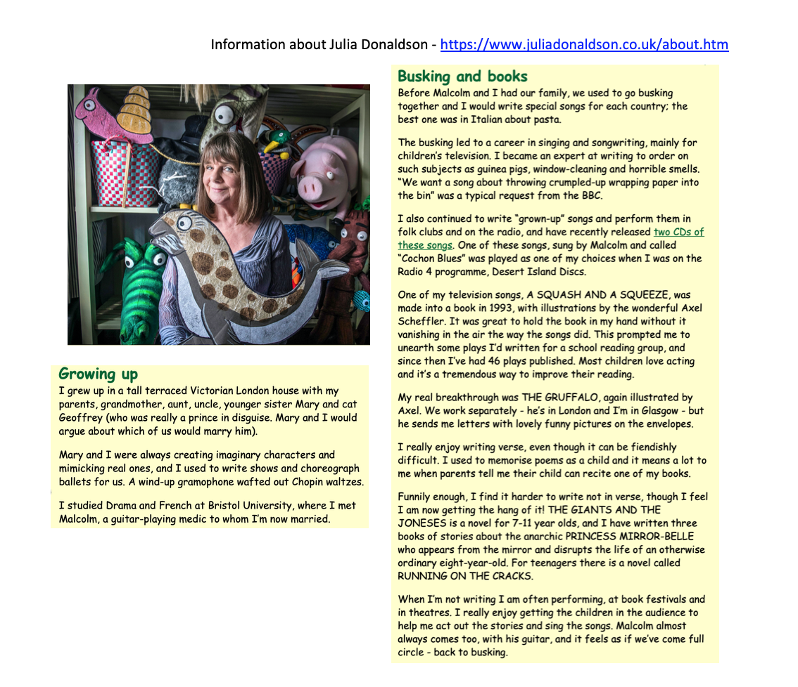

www.robinhoodMAT.co.uk
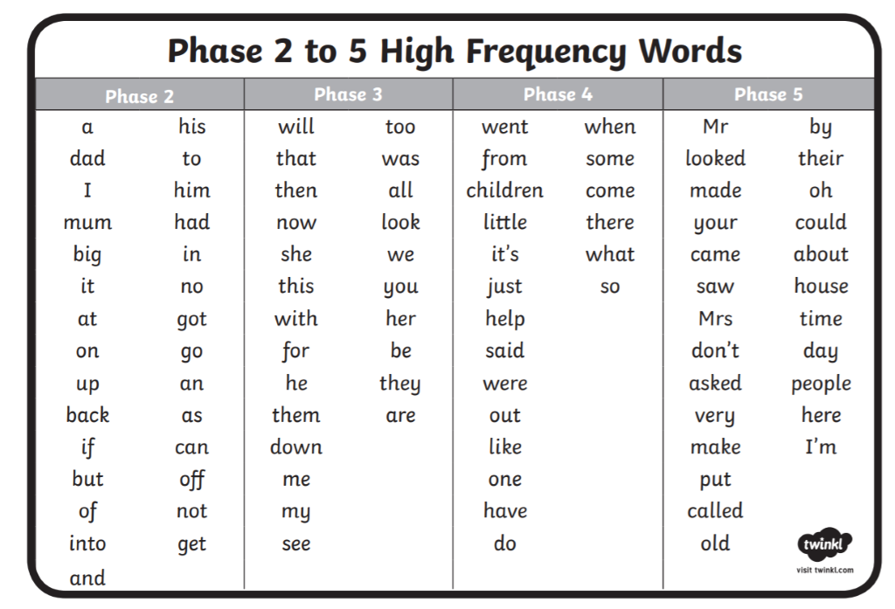

Tricky red words

Set 1 : I, a, the, of, put
Set 2: go, to, no, my, by
Set 3: he, me, we, she, be
Set 4: said, they, you, are, your
Set 5: was, all, come, some, into
Set 6: what, I’ve, have, like, so
Set 7: do, were, where, there
Set 8: little, one, when, their, people
Set 9: called, asked, could, should, would
Set 10: want, wanted, who, again, many

