Learning Project WEEK 3 - Viewpoints
Age Range: KS1
Weekly Maths Tasks (Aim to do 1 per day) | Weekly Reading Tasks (Aim to do 1 per day)
- Working on Numbots - your child will have an individual login to access this.  - Play Hit the Button - number bonds – 10 then 20, halves and doubles.  - Look in different rooms and count how many objects you can find. Then play this game to help you sequence the numbers.  - Practise making shapes on this online geoboard. Once you have made the shape from one view, can you make it from another? How do you know it is still the same shape?  - Get a piece of paper and ask your child to share what they have learned in their online Maths lesson.This could be pictures, diagrams, explanations, methods etc. They can be as creative as they want to be.  Daily Maths Lesson  - This site has daily Maths lessons which can be accessed online.  - These are available for Y1 and for Y2. | - Reading a variety of books at home. Your child could share a book everyday. This can be reading a book aloud everyday or sharing a book with an adult.  - Listen to the traditional story ‘Jack and the Beanstalk’.  You can read it here!  - Find a set of instructions for planting a seed or a bean. Read the instructions out aloud. Can you follow the instructions and plant a seed? Remember to keep watering it!  - Read a non-fiction book  - Read an article from a newspaper (online version) or magazine to an adult.
Weekly Phonics/Spellings  Tasks (Aim to do 1 per day) | Weekly Writing Tasks (Aim to do 1 per day)
- Daily phonics - your child to practice their sounds and blend words. Interactive games found on link below.  - Phonics play  - Top Marks  - Spelling  - Spell the days of the week  - Spell common exception words  - Spelling City  - Sumdog spelling games  Weekly Spellings  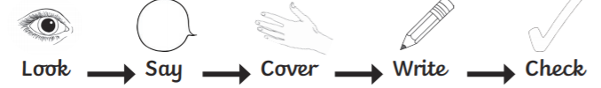  Practise the words on this list using look, say, cover, wrte and check. These words are tricky – you just need to learn how to spell them by practising!  Challenge: Can you write five different sentences, using the words above, without checking their spellings?  Year 1  Word 1st try 2nd try 3rd try  his  has  I  you  your  they  Year 2 – The sound /o/ spelt with ‘a’ after w and qu  Word 1st try 2nd try 3rd try  want  watch  wander  quantity  squash  quality  squabble | - Draw a picture of your house and label it.  - Write sentences using adjectives to describe a room in your house.  - Hide and seek: Write a set of instructions on how to find something in your bedroom. Think about the positional language to help find the object.  - Diary: Keep a diary of things that happen outside one of the windows in your house. Write down sentences using suffixes. Try to use exclamation marks. For example; A lady is walking a dog. A dog chased a cat up a tree!  - Draw a map of one of the rooms in your house. What symbols could you have? Where will you place items?
Learning Project - to be done throughout the week: View point
The project this week aims to provide opportunities for your child to learn more about different viewpoints. Learning may focus on physical viewpoints in terms of what you can see outside of the window at home, what others can see looking into your home and then progress onto personal viewpoints and of others.

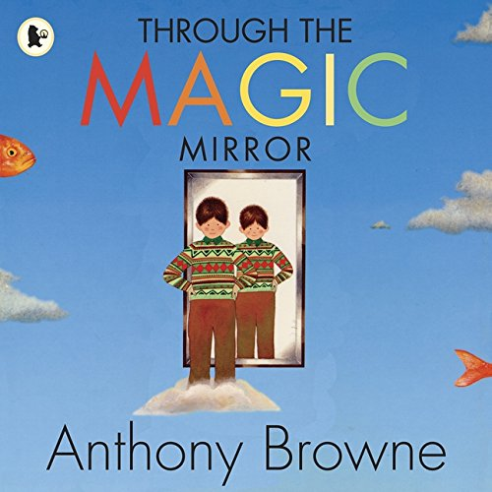
Using your senses: Ask your child to pick a window in the house. Ask them to stand there for a few minutes and take a look at what they can see and write or draw them down. Now ask them to try this activity again but this time ask them what they can hear? Write or draw these down. Ask your child to help find a piece of material in the house and then blindfold them. What can they see? Which sense do they use now? Ask them to now cover their ears and look outside the window. What do they hear?
A ‘feely bag’ - find six objects, such as a hairbrush, a tube of toothpaste, a packet of biscuits, an ice cream scoop, a packet of tissues and a wooden spoon. You will also need something to act as a blindfold. Imagine what it would be like if you could never see because you were blind and you had to learn to rely on your other senses instead. Play with a partner and see who guesses most of the objects.
Find a mirror in the house: What can they see? Imagine if they were able to walk into the mirror. What do they think you would see? Listen to the story ‘Through the Magic Mirror’ by Anthony Browne. Look at the illustrations in the book and discuss what is different. Can they create a story similar to ‘Through the Mirror’? Draw a story map first and plan their story. Using their story map, create their story. Think about what illustrations could be used to enhance the story. Find an example of a story map here!
Find a place in the house. Look around what they can see. Sketch what they can see. What is on the left hand side of them? What is the right hand side of them? Does it change if they sit in another part of the house? Make a list of all the things and compare.
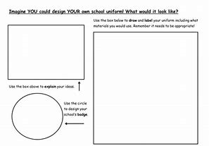
Read the stories: Goldilocks and the Three Bears, Jack and the Beanstalk and Cinderella. The characters will be going to see Judge Jenny ( who is a character from the clip whch they will be watching).Can they persuade Judge Jenny to see the story from their point of view. Watch these links to help Judge Jenny to decide. Now it’s their turn… read the stories Little Red Riding Hood, Three Little Pigs and Gingerbread Man. Imagine they are going to be one of the characters from the story and an adult is going to be Judge Jenny. What would they say to Judge Jenny? How could they persuade her?
School Uniform: Tell your child that they will be presenting to the School Council about the school uniform. Do they think it is a good idea to wear a uniform or are they against wearing a uniform? Can they write down why they think they should have a uniform and then write down why they shouldn't? Design a new uniform. What would they wear? Would it be the same for girls and boys? What would they say to the school council? How would they campaign? Would they have badges, posters, events and banners to help their debate.
Could you design a new school logo? Ask your child to think about their current logo now. What does it represent ? What could they add or change? Is there something that represents their school or area recently that people would recognise? Look at the shape of the logo. Would they keep it the same or change it?
Try exploring senses on Explorify. Brown and bumpy or If I couldn’t smell can be found in keystage 1 area, topic senses.Explorify. https://explorify.wellcome.ac.uk/en/activities/zoom-in-zoom-out/brown-and-bumpy
Additional learning resources parents may wish to engage with
Classroom Secrets Learning Packs - These packs are split into different year groups and include activities linked to reading, writing, maths and practical ideas you can do around the home.
Twinkl - to access these resources click on the link and sign up using your own email address and creating your own password. Use the offer code UKTWINKLHELPS.

#TheLearningProjects

