Week 9: Learning Project - Sport Online
Age Range: EYFS
Weekly Reading Tasks | Weekly Phonics Tasks
Monday- Talk to your child about sports day. Read together the information sheets about Sports Day at the end of the pack.  Practise reading and spelling the high frequency words attached below. Also continue to practise tricky words. | Monday- Daily Phonics - Practise the sounds your child is working on and blend words. This can be oral blending (e.g. spoken out loud c-a-t) or written if appropriate. Make your own bingo boards using this week’s keywords – use a hat / gift bag etc to put your flash cards into. Take it in turns to take a word out of the bag and mark off on your bingo board.  Daily phonics - Please see the link already sent in Tapestry to the daily Ruth Miskin RWI sessions on youtube.
Tuesday- Listen to stories linked to Sports Day Peppa Pig  Practise reading and spelling the high frequency words attached below. Also continue to practise tricky words. | Tuesday- Can your child think of rhyming words? Take it in turns to say a rhyming word i.e. cat, mat, bat, sat. Encourage your child to think about and play with rhyming words. The adult begins with the prompt I know a word that rhymes with cat, you need to put one on your head and the word is...hat.  Daily phonics - Please see the link already sent in Tapestry to the daily Ruth Miskin RWI sessions on youtube.
Wednesday-  Listen to stories linked to Sports Day The Large Family, Sports Day by Jill Murphy.  Practise reading and spelling the high frequency words attached below. Also continue to practise tricky words. | Wednesday- Play Phonics Pop - Once you have selected the sounds (you must select at least three sounds), click ‘Go’. Ask your child to listen to the new sound and click these to pop them. Also try and catch the aliens.  Daily phonics - Please see the link already sent in Tapestry to the daily Ruth Miskin RWI sessions on youtube.
Thursday- Develop listening skills by encouraging your child to listen to the BBC School Radio episode about sports.  Practise reading and spelling the high frequency words attached below. Also continue to practise tricky words. | Thursday- Repeat Buried Treasure from last week’s learning: Write out some real words and made up words (e.g. tud, jup, fub). Place these in a pile and using 2 containers, label one as ‘Treasure’ and the other as ‘Bin’. Can your child read the word and decide if it is real? If it is real it goes in the treasure chest, if not it goes in the bin.  Daily phonics - Please see the link already sent in Tapestry to the daily Ruth Miskin RWI sessions on youtube.
Friday- Read a range of stories at home- enjoy reading them together. Talk to your child about their likes and dislikes in the story.  Practise reading and spelling the high frequency words attached below. Also continue to practise tricky words. | Friday- Provide your child with some simple words linked to sport e.g. ran. Say the word in sounds e.g. r-a-n, h-o-p, j-u-m-p Ask your child to repeat the sounds and then write the sounds if they are able to.  Daily phonics - Please see the link already sent in Tapestry to the daily Ruth Miskin RWI sessions on youtube.
Weekly Writing Tasks | Weekly Maths Tasks- Positions
Monday- Can your child talk about all the different sports they know? Can they have a go at writing them a list (i.e. run, jump, skip)? Talk about why people write lists and how-to layout a list. | Monday- Listen to this song and watch a short video to learn positional language.  Play the prepositional game at the end of the pack.  White Rose Weekly Maths White Rose Maths -click for Summer Term guidance.
Tuesday- Discuss what is the most important thing to remember on sports day – see slides below. Ask your child to write a simple sentence about winning a race or taking part in a race. Encourage them to use their phonic knowledge to sound out. | Tuesday- Play positional language Hide and Seek- Choose a selection of items and hide them. Ask your child to count out loud while you’re doing this. Give them clues about the positions of the objects, e.g. it’s under the chair  White Rose Weekly Maths White Rose Maths -click for Summer Term guidance.
Wednesday- Ask your child to draw a picture of themselves doing something sporty or them taking part in your obstacle course. i.e. running, jumping, a cartwheel. Can they label the picture or write a simple sentence e.g. I can hop. | Wednesday- Listen to ‘We’re Going on a Bear Hunt’. Talk about the positional language used in the story – through, over, under. Create a story in the house using these words-over, under, though, behind, next to, opposite, around.  White Rose Weekly Maths White Rose Maths -click for Summer Term guidance.
Thursday- Use this animated letter formation tool to help your child practise letter formation. You can select those they find most challenging. Practise writing your first name and your surname. Practise writing the following letters s, p, o, r, t, s, d, a, y, can you write the letters onto a line? Take care with the letters p and y, remember the descender (the tail) comes below the line. | Thursday- Encourage your child to jump, hop or skip. Give them directions as they do this e.g. jump forwards 5.  White Rose Weekly Maths White Rose Maths -click for Summer Term guidance.
Friday- Support your child to practise writing the tricky words for this week.  How fast can they write the word? | Friday- Make a positional language picture- cut out a selection of 2d shapes. Give your child positional instructions to create a picture e.g. put the square in the middle of your page. White Rose Weekly Maths White Rose Maths -click for Summer Term guidance.

Learning Project - to be done throughout the week
The project this week aims to provide opportunities for your child to learn more about sports and games. Learning may focus on the history of sport, sporting-heroes, physical challenges and performance.
Ball Games
- Play a game of catch with a ball - when you drop the ball, you lose a point. You could record points using a tally chart and count up who has the most points at the end. CHALLENGE: See if you can catch the ball standing further apart, catch with one hand or use a smaller ball.
Play Skittles
- If you have a set of skittles, you’re ready to go, if not you can make your own skittles using plastic bottles. Take a plastic bottle and partly fill with soil/ stones or sand to weigh it down. If you don’t have plastic bottles available, you could use tin cans for an alternative version. Ask your child to count how many skittles there are to begin with. Roll the ball at the skittles and ask your child to count how many they have knocked over. Can they work out how many are left? CHALLENGE: You could write this out as a subtraction number sentence e.g. if you start with 5 skittles and knock over 2 your child would write 5 - 2. Ask them to count how many are left to find the answer 5 - 2 = 3

Competition Time
- Have a time challenge. Give your child an action to do e.g. hop, skip, jump, clap or star jump. How many can they do in one minute? Keep a record of the scores. Ask everyone in the house to have a go!

Parts of the Human Body
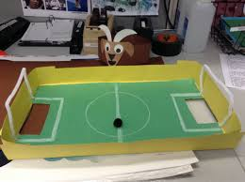
- Ask your child which parts of their body they use to run? To do a handstand? Draw the parts of the body and for a challenge ask them to label them using their phonics knowledge.

Create your own Junk Modelled Football Pitch
- Using a lid of a shoe box or similar container, help your child to cut out two holes on each end as the goals. If you have green card or paper, stick this in the base, if not you can colour in plain paper using a crayon. Draw out the marking on the pitch using crayons or felt tips. When finished, stand your football pitch on a box on the table. Using something ball-like (e.g. a sweet), take turns aiming at your partner’s goal whilst the other tries to save the goal. If you score you get to eat the sweet! CHALLENGE: Write instructions to play your game e.g. 1. Put the ball in. 2. Flick at the goal. 3. Eat the sweet!
STEM Learning Opportunities #sciencefromhome
Brilliant Bodies
Try testing your body by seeing how long you can balance for, try balancing on different parts of your body. Record how long you were able to balance. Compare times and discuss with your family.
Mindfulness - Helping your child to have some focused mindfulness time is a great way to help them cope with any difficult feelings or emotions that they might be experiencing at the moment. Mindfulness activities also contribute to brain health and general wellbeing. Start with short amounts of time and build up as your child develops the ability to be still, calm and quiet.
After your child has done something energetic, like dancing, have them take time to lie down with their hands on their chest. Ask them to close their eyes and tune into the feeling of their heart pumping and their chest rising and falling with each breath. Now ask them to bring their attention to their toes, feeling into their little toes and across to their big toes. You might need to gently place your hand on that part of their body to help them feel where they need to focus. Now ask them to bring their attention up to their ankles, then their calves, shins, knees, etc. Keep guiding them to gradually bring their attention in an upwards direction. When they get back to their chest, ask them to again tune into the beating of their heart and the feeling of their breath. Have them remain here, just breathing and staying still, for 1 or 2 minutes.
Additional learning resources parents may wish to engage with
White Rose Maths online maths lessons. Watch a lesson video and complete the worksheet
Numbots. Your child can access this programme with their school login.
IXL Click on Maths, Reception. There are interactive games to play and guides for parents.
Talk for Writing Home-school Booklets are an excellent resource to support your child’s speaking and listening, reading and writing skills.
#TheLearningProjects
in collaboration with
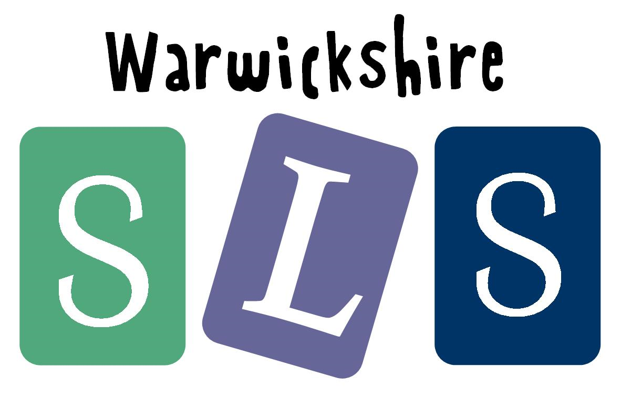
www.robinhoodMAT.co.uk