Week 9 -Learning Project – Sport- online
Age Range: Y5/6
Weekly Reading Tasks | Weekly Spelling Tasks
Monday- Ask your child to read the sports pages of a newspaper or the sports pages on a website and consider the language used. They could add interesting language to a sports’ word bank. | Monday- Can your child list sport related noun phrases and verbs that correspond with each letter of the alphabet? This will support their writing tasks.  Weekly spellings:  Words that are synonyms and antonyms + 2 spelling appendix words Spelling List  bellowed  screeched  squealed  shrieked  squawked  whispered  murmured  breathed  sighed  muttered  harass  hindrance
Tuesday- Here is a reading comprehension activity about circus performers. Ask your child to read the text quickly and accurately and complete the questions. | Tuesday- Can your child complete this word search which focuses on words ending in -cial or -tial? Can they find the meanings of these words too? They could show this by putting the words into a different sentence correctly.
Wednesday- Ask your child to listen to and read along with Arundel Swimming Pool. Ask your child to summarise each verse using only one word. | Wednesday- Ask your child to create their own sporting wordsearch. This could include the names of athletes, sports or sporting equipment. There are some different templates here if you would like to use one.
Thursday- Read the text called The Wexbridge Flyer from the literacy shed pack 5. Have a look at the questions below the text and answer them. There are answers to the questions for you to have a look at. | Thursday- Can your child unscramble these sporting words: queenmipt, poicmlys, tannidmob, cagminssty & pochmashpini.
Friday- Ask your child to consider the actions of a character in a book they’ve recently read. Do they agree or disagree with the actions? They should give reasons for their opinions and justify them verbally using evidence from the text. | Friday- Pick 5 Common Exception words from the Year 5/6 spelling list. Challenge your child to spell them as you throw a ball to each other. Every time the ball is thrown the next letter must be said.
Weekly Writing Tasks | Weekly Maths Tasks- Position and Direction  Choose a task or tasks from each day. These are to be used flexibly
Monday- Visit the Literacy Shed for this wonderful resource on The Catch. Watch the film and use the crib sheet to stop it at the appropriate time. Talk though the questions that you are given. | Monday- Ask your child to create their own reflection, rotation AND translation poster using the attached information to help you.  Bitesize Maths online daily maths lessons with worksheets  White Rose Maths online daily maths lessons use bitesize link for worksheet  CODE Maths Hub Daily Fluency Activities - Day 1 Week 4
Tuesday- Look at ‘The Catch’ again and use the template to write a haiku. There are other examples of Haikus here. | Tuesday- Place several household objects on the ground indoors or in the garden spaced apart. Blindfold your child using a scarf and using the positional language, such as turn left, right, forwards, clockwise etc, give them instructions to lead them to the items. You could say something like: “Turn 90 degrees left, move forwards 3 spaces.” Can your child follow the given instructions to find the object?  Bitesize Maths online daily maths lessons with worksheets  White Rose Maths online daily maths lessons, use bitesize link for worksheets  CODE Maths Hub Daily Fluency Activities - Day 2 Week 4
Wednesday- Ask your child to choose a sports person they admire. Encourage them to create a biography which tells the story of their life in chronological order. Think about using the headings; Early life, Hopes and Dreams, and Sporting Success. More and different subheadings could be used too! Use the headings to research your sports person. | Wednesday- Create your own translation challenges like the ones attached  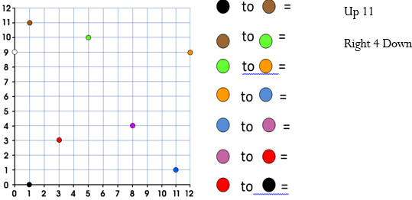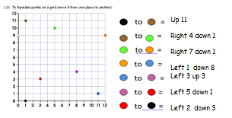  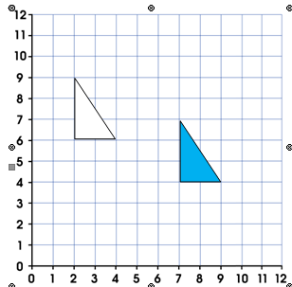  As an extra challenge you may want to practise your translation across 4 quadrants  Bitesize Maths online daily maths lessons and worksheets  White Rose Maths online daily maths lessons (use bitesize link for worksheet)  CODE Maths Hub Daily Fluency Activities - Day 3 Week 4
Thursday- Use the research you collected the previous day to create your biography. Don’t forget to re-read your writing and check punctuation and spelling. | Thursday - Play catch. Each time the ball is caught, count up in a particular multiple (this could be any number between 2 and 100). If the ball is dropped, start again. It can be made harder by spacing out or by giving a higher target number.  Bitesize Maths online daily maths lessons with worksheets  White Rose Maths online daily maths lessons  CODE Maths Hub Daily Fluency Activities - Day 4 Week 4
Friday- Create a persuasive leaflet for a new school sports club.  They should use persuasive language including modal verbs (e.g. will, should) and adverbs of possibility (certainly, probably). | Friday - Play Medal Muddle – to help sort out the Olympic Medal Table.  Hints – you may want to choose a specific country to start  - Write down each country on a piece of paper and cut it out so that you can move them around.  Bitesize Maths online daily maths lessons  White Rose Maths online daily maths lessons  CODE Maths Hub Daily Fluency Activities - Day 5 Week 4

Learning Project - to be done throughout the week
The project this week aims to provide opportunities for your child to learn more about sports and games. Learning may focus on the history of sport, sporting-heroes, physical challenges and performance.

- Sport Genius- Ask your child to research about sporting history and see how many different facts they can find out about sports from the past. Ask them to create their own sporting trivia quiz which they can test out on members of the household.

- Sporting Timeline - Place different sporting events from the last 100 years onto a timeline.

- Sporting Heroes- Get your child to select their favourite sporting star. Draw a portrait of them in the style of the famous pop artist Roy Lichtenstein using felt tip pens or paint.

- Name that Sport - Get your child to create an orienteering map of your home/garden. At each location they will need to create a question relating to a sport e.g. When did Liverpool last win the Premier League? The answers can then be recorded on an orienteering sheet. How about giving them a challenge? Can they create an answer that begins with the letter of the next location? Get your child to test it out on a family member.

- Beat It!- Begin by getting your child to measure their resting heart rate by counting how many beats in a minute. Then get them to carry out an exercise e.g. running, skipping, star jumps etc. for 3 minutes. Once they have completed this they are to carry out a recovery activity e.g. walking or sitting and see how long it takes for their heart rate to go back to normal. Ask them to repeat this with different recovery exercises to see which is the most effective at getting their heart rate back to normal the quickest. Can they create a way of showing their results?

- Anyone Can Be a Champion!- This activity is all about exploring the diversity of sport. Ask your child to research the history of the Paralympics . Discuss why we have the Paralympics. Get your child to create a poster which presents the importance of the Paralympics and the range of different sports there are.

- Mindfulness - This week we will bring our attention to different parts of our body as we do something called a body scan. After your child has done something energetic, like dancing or kicking a ball around the garden, have them take time to lie down with their hands on their chest. Ask them to close their eyes and tune into the feeling of their heart pumping and their chest rising and falling with each breath. Now ask them to bring their attention to their toes, feeling into their little toes and across to their big toes. Keep the focus here for a few slow breaths. Now ask them to bring their attention up to their ankles, then their calves, shins, knees, etc. Again, pausing at each stage for a few slow breaths. Keep guiding them to gradually bring their attention in an upwards direction. When they get back to their chest, ask them to again tune into the beating of their heart and the feeling of their breath. Have them remain here, just breathing and staying still, for about 10 minutes.

STEM Learning Opportunities
Heart Beaters
- Can you tickle yourself? How many litres of blood do you have in your body? How many times does your heart beat in a day? Test your family with a body trivia quiz. Create your own cards or download some from here: https://bit.ly/2RFJVRN
- The complete resource can be downloaded here: https://bit.ly/3a9VtTU
- Can you spot the odd one out? Use the activity here to find out!
Additional learning resources parents may wish to engage with
- Maths
- Times Table Rockstars and Numbots. Your child can access both of these programmes with their school logins. On Times Table Rockstars, children should aim to play Soundcheck for 20 minutes daily.
- IXL online. Click here for Year 5 or here for Year 6. There are interactive games to play and guides for parents.
- CODE Maths Hub Daily Fluency Activities - Week 4
- https://www.topmarks.co.uk/maths-games/daily10 - arithmetic challenges
- Sumdog activities
- BBC Bitesize - Lots of videos and learning opportunities for all subjects.
- Classroom Secrets Learning Packs - Reading, writing and maths activities for different ages.
- Twinkl - Click on the link and sign up using your email address and creating a password. Use the offer code UKTWINKLHELPS.

- Y5 Talk for Writing Home-school Booklets and Y6 are an excellent resource to support your child’s speaking and listening, reading and writing skills.
#TheLearningProjects
in collaboration with
www.robinhoodMAT.co.uk

