Learning Project – Space Online
Age Range: EYFS
Weekly Reading Tasks | Weekly Phonics Tasks
Monday- Listen to Whatever Next?  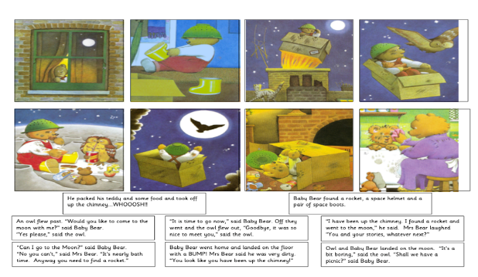  Practise reading and spelling the high frequency words attached below. Also continue to practise tricky words. | Monday- Play the online game ‘Picnic on Pluto’. If your child is not at the stage of reading independently, you could sound the words out for them to blend together.  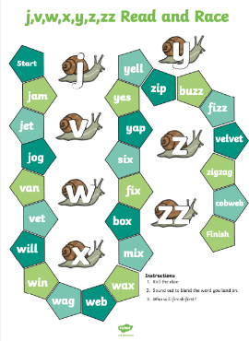  Daily phonics - Please see the link already sent in Tapestry to the daily Ruth Miskin RWI sessions on youtube.
Tuesday- Visit Storytime from Space and let your child listen to the Story Time video of A Moon of My Own. Read the space sentences below.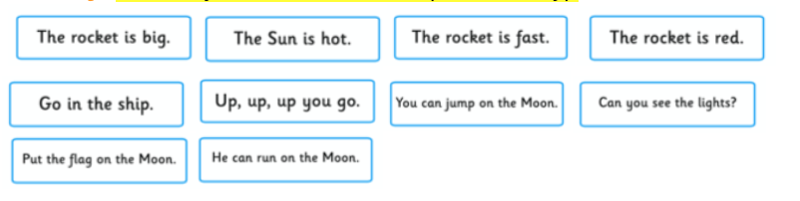  Practise reading and spelling the high frequency words attached below. Also continue to practise tricky words. | Tuesday- Play ‘I Spy in Space’. ‘I spy, with my little eye, something beginning with t’. CHALLENGE: You can include these sounds ch, sh, th.  Daily phonics - Please see the link already sent in Tapestry to the daily Ruth Miskin RWI sessions on youtube.  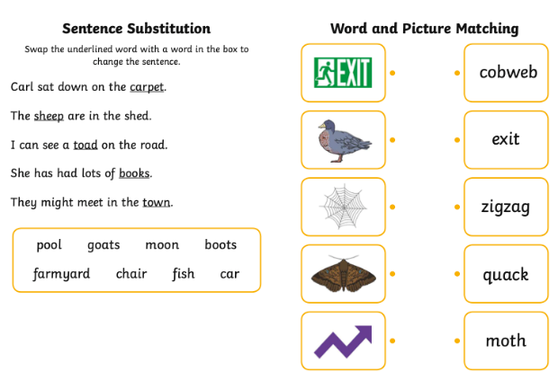
Wednesday- Listen to a space themed online story, Aliens Love Underpants, Roaring Rockets and using the space stories as a starting point, ask your child to make up their own story about space. It could use the same characters or settings as one of the stories you have shared together.  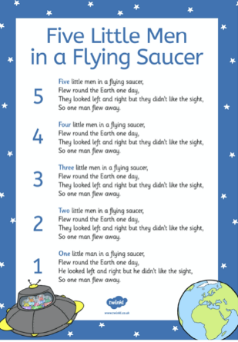  Practise reading and spelling the high frequency words attached below. Also continue to practise tricky words. | Wednesday- Write different sounds on paper (maybe re-use the sounds from a previous project). Put the sounds together to make different words only changing the initial sound e.g. t-i-n (tin), b-i-n (bin), ch-i-n (chin).  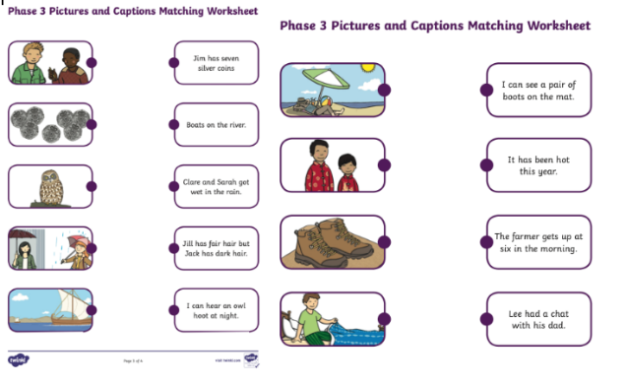  Daily phonics - Please see the link already sent in Tapestry to the daily Ruth Miskin RWI sessions on youtube.
Thursday- Ask your child to draw a picture of one of the events from their made up space story. Can they explain what’s happening in the picture? Or, for more of a challenge, can they draw a book cover for their space story?  Practise reading and spelling the high frequency words attached below. Also continue to practise tricky words. | Thursday- Can your child list things they would see in space that begin with the letters s, p, a, c & e. Practice writing these letters in space (in the air) using their finger or a pencil and then in their book – writing them onto the line - take care with p!  Daily phonics - Please see the link already sent in Tapestry to the daily Ruth Miskin RWI sessions on youtube.
Friday- Visit Oxford Owl ebooks. Look at the picture book: ‘In the Sky’. Talk about the story together. What is happening on each page?  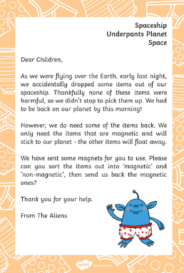  Practise reading and spelling the high frequency words attached below. Also continue to practise tricky words. | Friday- Play, ‘Pick a Picture’. You can orally sound out the word for your child for them to blend together if they are not yet at the stage of reading independently.  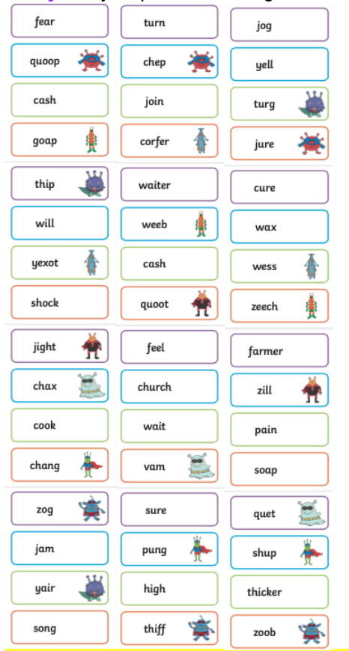  Daily phonics - Please see the link already sent in Tapestry to the daily Ruth Miskin RWI sessions on youtube.
Weekly Writing Tasks | Weekly Maths Tasks- Length and Height
Monday- Ask your child to draw their own alien and label it. Can they create a fact file for their alien using sentences? E.g. My alien lives on Mars. | Monday- Time – Set a timer for a minute (or half a minute) and count how many actions your child can do in the time e.g. star jumps, hops or writing their name.  Encourage Mathematical thinking and reasoning: Describing  How many star jumps did you do? How many hops? Which did you do more of? Did you do more or fewer than last time? You did more jumps – does that mean you are getting faster or slower?  Reasoning what do you think you can do more of in a minute, star jumps or twirls, when do you think that is? Try again - Can you do more this time? What makes you think you are getting faster? Or slower? Opening Out Can you think of some other actions you can do in a minute? Writing your name? Singing happy birthday all the way through? Can you put your coat and shoes on in a minute? Stand up with your eyes shut: sit down when you think a minute is over? How close were you? Did you think a minute was a shorter or longer time than it really is?  Recording Record how many jumps you do each time, so we can track, what do the records show?  White Rose Weekly Maths White Rose Maths -click for Summer Term guidance.
Tuesday- Write an invitation to the alien to invite them to your very own space party. | Tuesday- Ordering familiar events – talking about days of the week and calendars. Take some photos of regular events of the day or draw some pictures with your child to make a timetable.  The activity: When you are all familiar with the timetable, take all the pictures and ask your child to put them in order. Muddle them up and ask them to help you sort them. Describing: All the pictures have come off. Can we put on all the activities in order? What do we do first? Which activity do we do first/next/after/before? What day comes after today? What day will it be tomorrow? What day was it yesterday? How day comes after / before Tuesday? How many sleeps is it until the weekend? Reasoning: How do you know that goes there? First, we have lunch, then we wash our hands. Oh, that isn’t right? Why not? Is it right that we go home at the beginning of the day? Invite the children to make up ‘silly’ sequences and explain why they are silly. What things would you like to do in a day? In what order and why? What would your child’s favourite be? How many sleeps will it be to a certain event?  White Rose Weekly Maths White Rose Maths -click for Summer Term guidance.
Wednesday- Your child can draw out or write their own menu for an alien. What does an alien eat? Moon-burgers, star biscuits or fruit rockets. Click here for more ideas. | Wednesday- Comparing capacities/ counting. Set up a water tray or fill the sink with water or coloured water some plastic bottles and flasks of different dimensions including some plastic cups. Allow you child to have free time with the containers and water! Question – We are going on a picnic and we want to take a drink to the park (Lemonade). Which bottle will hold the most.? Describing: what do you notice about the bottles? How are they different? What happens if you pour this one into this other one? Reasoning: How can we find out which one holds the most? How do we know which one holds more? Opening out: How many cups will they each fill up? Can we put them in order from the smallest to the biggest/from which holds the most to the least? Recording: can we put labels on the bottles to help us remember how much is in them?  White Rose Weekly Maths White Rose Maths -click for Summer Term guidance.
Thursday- Task your child with designing their own spaceship. Can they describe how the machine would move and label it using verbs? | Thursday- Thursday- Using resources from yesterday Allow you child to have free time with the containers and water!  How much lemonade do we have to make so that everyone gets one cup? Or Two cups? Pour one cupful of coloured water into a transparent containers- some tall, thin, short, fat, flat - Discuss what happens to the water level in each and why. Think about full, empty, half full, half empty, nearly full, nearly empty, over flowing! 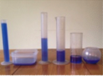  White Rose Weekly Maths White Rose Maths -click for Summer Term guidance.
Friday- Linked the Aliens letter (reading activity), write a list of objects that are magnetic and not magnetic. How many objects can you list? | Friday- In bags, place a variety of different objects, for example, one big box, some small building blocks or many tiny gems. Invite the children to explore the bags and to predict which of the bags will be the heaviest before testing their predictions using a balance scale. Or Create moon rocks of different weights by wrapping items in tinfoil. Add some items that are large and light, such as a big polystyrene ball or small and heavy, such as a rock.  Provide a balance scale for children to weigh and compare the items. Encourage the children to make predictions and talk about what they have found out. Were they correct?  White Rose Weekly Maths White Rose Maths -click for Summer Term guidance.

Learning Project - to be done throughout the week
The project this week aims to provide opportunities for your child to learn more about space. Learning may focus on our Solar System, the Sun and the Moon. It could look at life in outer space from the view of an astronaut and travelling through space.
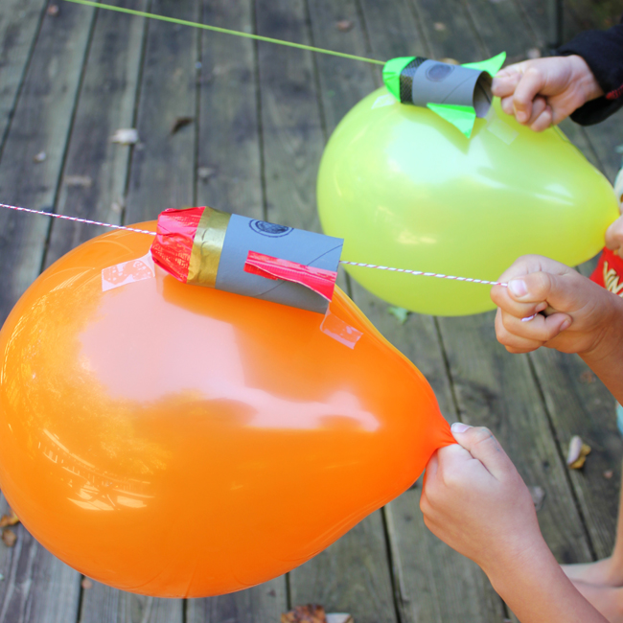
Remarkable Rockets
- Use junk modelling or craft items you have around your house to create your own rocket. Toilet roll tubes are a good starting point. You could have rocket races in the garden:
  - Tie a string up at an angle or use the washing line.
  - Blow up a balloon and sellotape it to your rocket. Hold the end of the balloon but do not tie it.
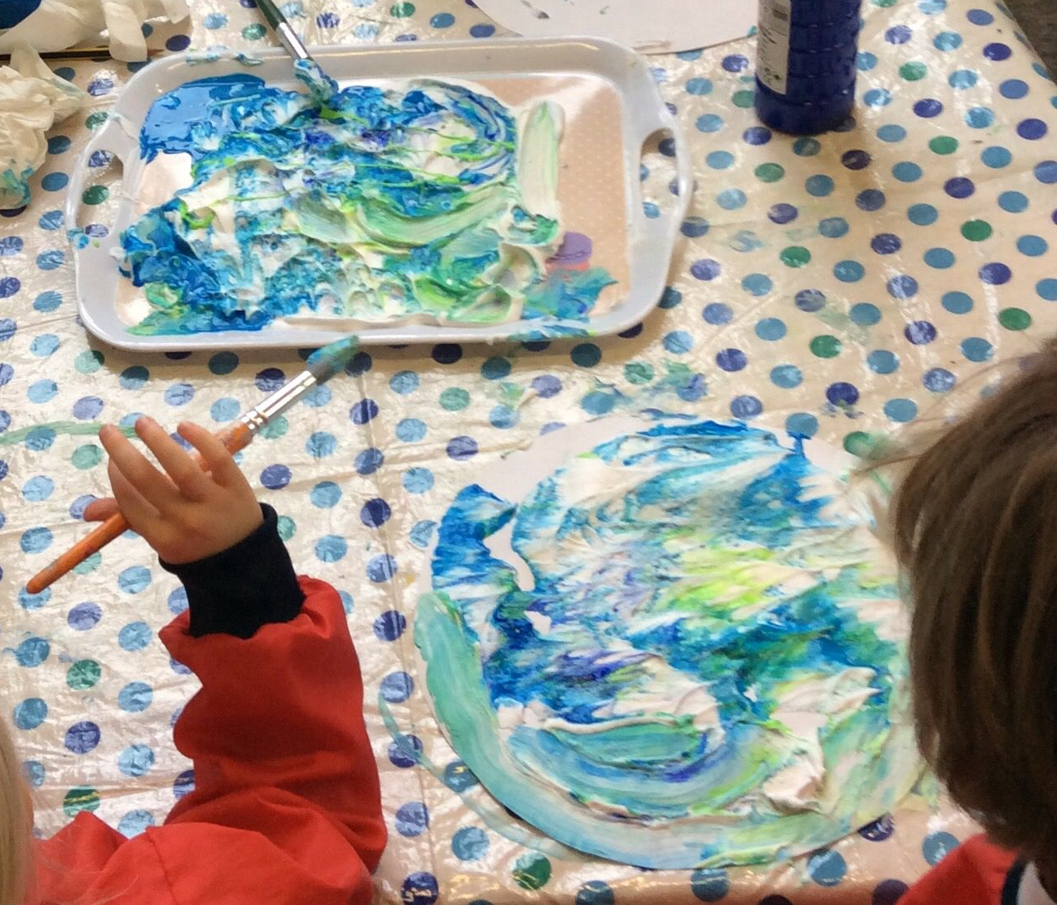
  - Let the balloon go and watch your rocket fly!

Make a Textured Planet
- Work with your child to create a replica of a planet. You could papier mache a balloon, or colour, paint or stick bits of materials on to the card to create textured effects. This shaving foam paint technique (see picture) creates a great textured finish when dry. Simply spray shaving foam onto a plate and drop in food colouring or poster paint.

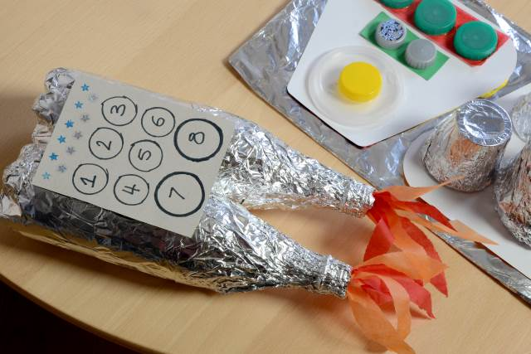
Explore Space Online
- Support your child in looking at the Earth from space using the Google Earth programme and identifying simple features such as water.
- Can you find your home? What does your child notice about the surrounding area?

Phone Home
- Create a space phone with your child using items from around the home. Get them to practise forming numerals correctly to create the buttons.
- Make a space phone book to support roleplay. Ask your child to draw a picture of a different alien on each page and write a phone number for them.

Have a Space Themed Party/Picnic
- Support your child to use tin foil to create shiny space suits for their teddies and dolls. They could have a space-themed teddy bear’s picnic afterwards where they share the biscuits in the next activity!
- Make yummy star biscuits to share at the picnic. Click here to find instructions on how to support your child in making simple star biscuits. They could share them at their space themed teddy bear’s picnic. Share photographs of your space themed picnic on to Tapestry.
Mindfulness
To link to the space theme, how about helping your child make a space mobile to use as a relaxation tool. You could do this by cutting out some cardboard stars and dangling them from a coat hanger (feel free to be more creative!). Find somewhere to hang the mobile so your child can lay down underneath and gaze up at the stars. It will work well outside with a gentle breeze to make the mobile move. Encourage your child to keep their body and their mind still. Then focus on watching the stars move and the feeling of their breath entering and leaving their body. Encourage your child to stay here for as long as they find comfortable.
STEM Learning Opportunities #sciencefromhome
Mission X – Astro Agility Course
- Complete an agility course to improve movement skills, co-ordination, and speed. Record your speed and see if you can get faster with practise. See here.
- Sign up and access all of the Mission X resources here.
Additional learning resources parents may wish to engage with
White Rose Maths online maths lessons. Watch a lesson video and complete the worksheet (can be downloaded and completed digitally).
Numbots. Your child can access this programme with their school login.
IXL Click on Maths, Reception. There are interactive games to play and guides for parents.
Talk for Writing Home-school Booklets are an excellent resource to support your child’s speaking and listening, reading and writing skills.
#TheLearningProjects
in collaboration with
