Week 10: Learning Project - The Rainforest Online
Age Range: EYFS
Weekly Reading Tasks | Weekly Phonics Tasks
Monday- Watch Go Jetters: Amazon Rainforest. Can your child tell you where the tree frog was found? What sound did it make? Which rainforest insect steals the picnic? What happens when the tree frogs aren’t there to eat the ants?  Practise reading and spelling the high frequency words attached below. Also continue to practise tricky words. | Monday- Ask your child to find different things around the house/garden. Can they segment each word into sounds i.e. c-u-p (cup), b-e-d (bed) t-ea (tea), ch-air (chair)? If they are able, they could write these too.  Daily phonics - Please see the link already sent in Tapestry to the daily Ruth Miskin RWI sessions on youtube.
Tuesday- Help your child to look through cookery books for a recipe involving cocoa/chocolate. If you have the ingredients, make the sweet treat!  Practise reading and spelling the high frequency words attached below. Also continue to practise tricky words. | Tuesday- Think of words to describe the rainforest animals - each word should start with the same letter i.e. mad, munching monkey or large, loving lion.  Daily phonics - Please see the link already sent in Tapestry to the daily Ruth Miskin RWI sessions on youtube.
Wednesday- Ask your child to use pictures from a familiar story book to make up their own story or to retell their favourite story.  Practise reading and spelling the high frequency words attached below. Also continue to practise tricky words. | Wednesday- Daily Phonics - Practise the sounds your child is working on and blend words. This can be oral blending (e.g. spoken out loud a-n-t) or written.  Play s,a,t,p,i,n read and race to support confidence and fluency- see end of pack.  Daily phonics - Please see the link already sent in Tapestry to the daily Ruth Miskin RWI sessions on youtube.
Thursday- Enjoy listening to online stories together including: Slowly Said the Sloth  Practise reading and spelling the high frequency words attached below. Also continue to practise tricky words. | Thursday- Play ‘I Spy in the Rainforest’. ‘I spy, with my little eye, something beginning with t’. CHALLENGE: Change it to ‘I spy, with my little eye, my word includes the digraph ee’ - ‘Tree’.  Daily phonics - Please see the link already sent in Tapestry to the daily Ruth Miskin RWI sessions on youtube.
Friday- Enjoy listening to online stories together including: The Tiger Who Came To Tea.  Practise reading and spelling the high frequency words attached below. Also continue to practise tricky words. | Friday- Play the Word Machine - Ask your child to read each word carefully. Match the correct word to the picture. If you get it right, you will hear a clap. Click ‘Next’ and have a go at another word.  Daily phonics - Please see the link already sent in Tapestry to the daily Ruth Miskin RWI sessions on youtube.
Weekly Writing Tasks | Weekly Maths Tasks- Number Recognition and Counting
Monday- Say or write a list of all the animals you would find in the rainforest. CHALLENGE: Can your child think of an animal for each letter of the alphabet e.g. a=alligator, b=bird. | Monday- Use this tens frame to practise making different amounts. Or, your child can practice making amounts to 10 using different objects from the garden e.g. leaves.  White Rose Weekly Maths White Rose Maths -click for Summer Term guidance.
Tuesday-  Click here to watch Go Jetters Amazon Rainforest, South America  Talk about the rainforest with your child and ask: What can you see? What can you hear? Ask your child to draw a picture of the rainforest and write a sentence about what they can see or hear. | Tuesday- Encourage your child to think about where we see 6,7,8 in everyday life and make collections of 6,7,8 objects.  Draw a part-whole diagrams with one of the parts or the whole missing to represent different ways of making 6, 7 or 8.  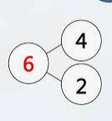  White Rose Weekly Maths White Rose Maths -click for Summer Term guidance.
Wednesday- Use this animated letter formation tool to help your child practise letter formation. You can select those they find most challenging. Practise writing your first name and your surname. Practise writing the following letters, can you write them onto a line? r,a,i,n,f,o,r,e,s,t,. Take care with the letter ‘f’ make sure the ‘tail’ comes below the line. | Wednesday- Play this Ladybird Spots-Counting, Matching and Ordering Game. You can tailor the difficulty to your child’s level.  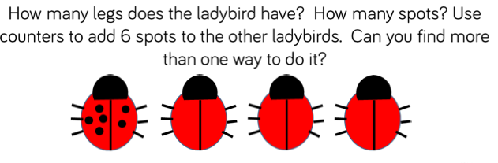  White Rose Weekly Maths White Rose Maths -click for Summer Term guidance.
Thursday- Using the story The Tiger Who Came To Tea, draw a picture of the tiger and label the picture using words to describe him e.g. stripy fur, sharp teeth. | Thursday Go on a mini beast hunt. How many legs can you see? Make drawings of the creatures you find. How many legs did you find?  Try writing you own number sentences to represent the total numbers of legs.  e.g 1 spider plus 1 ladybird = ?? legs
Friday- Ask your child to create a rainforest animal mask then talk about the sounds that different animals make. CHALLENGE: Can they write a sentence to describe the animal e.g. I like the monkey. He is cheeky. He jumps in the trees. | Friday- Use a teddy and count forwards and backwards making deliberate mistakes. Can your child spot the mistakes? Mistakes can include omitted numbers, repeated numbers or a number in the wrong place. CHALLENGE: Ask your child to spot the mistake when the numbers are written down.  White Rose Weekly Maths White Rose Maths -click for Summer Term guidance.

Learning Project - to be done throughout the week
The project this week aims to provide opportunities for your child to learn more about the world’s rainforests. Learning may focus on the plants, animals and insects that inhabit the rainforest, food that originates there and weather patterns. It could look at plants and animals that can be found in the garden too.
Which Animals Live in the Rainforest?
- Watch this video about animals in the rainforest. Can your child tell you about some of the animals that live in the rainforest? Can they remember any facts? Can they describe the animals?.
- Ask your child to make their own explorers outfit (e.g. binoculars, sunhat, backpack) and head out to the garden or on your daily walk. What creatures can your child find? Are they similar to any you might see in the rainforest? Take photographs.

Draw or paint a picture of a Rainforest Animal
- Ask your child to draw or paint a picture of a rainforest animal.

Play the Animal Jungle Quiz
- Listen to the clues. Can you match the clue to the correct animal?
- Click here to create your own jungle. Drag the animals onto the picture. Where do you think the animals should go? Why? i.e. on the ground, in the trees…
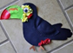
Make a Collage of a Rainforest Animal
- Use collage to create your own rainforest animal using recycled materials from around the house.

Make an Animal Home
- Create an animal home e.g. a bug hotel using things from the garden. Use a plastic tub or cardboard box. Ask your child what the animal will need in the home in order to survive.
STEM Learning Opportunities #sciencefromhome
Rainforest Materials
- A rainforest has lots of tall trees and grows in warm countries that have a lot of rain. People use the wood from the trees to make paper and furniture. They also take lots of ingredients like sugar and oil to make food. Here you can find a list of food and ingredients that grow in rainforests.
What plants can we find in the garden? Can you name the different parts of a plant? Stem, leaves, branches, roots, flower? Try using some of the material found in your garden to make something useful. For example, a nature paint brush.
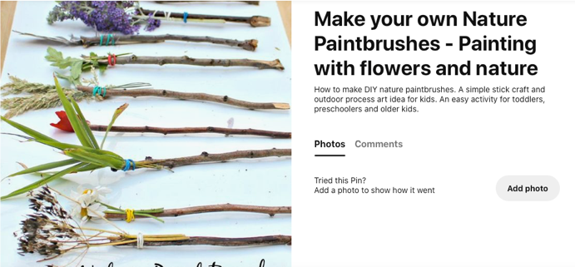
Mindfulness - Helping your child to have some focused mindfulness time is a great way to help them cope with any difficult feelings or emotions that they might be experiencing at the moment. Mindfulness activities also contribute to brain health and general wellbeing. Start with short amounts of time and build up as your child develops the ability to be still, calm and quiet.
You can use this rainforest music or sit outside in the garden with the sound of nature around you as your focus. Have your child sit or lie down in a comfortable position with their eyes closed. They might like to use a snuggly blanket, a cuddle toy or a cushion so that they feel cosy, safe and relaxed. Ask them to close their eyes and say still. All they need to do is listen to the music / sounds of nature. If any thoughts pop into their head, you can tell them that the thoughts are just like clouds and float away. Every time a thought comes along, just let it float away like a cloud and continue listening to the sounds. You can do this for 2 or 3 minutes every day, or for as long as your child feels able to focus.
Additional learning resources parents may wish to engage with
White Rose Weekly Maths White Rose Maths -click for Summer Term guidance
Numbots. Your child can access this programme with their school login.
IXL Click on Maths, Reception. There are interactive games to play and guides for parents.
Talk for Writing Home-school Booklets are an excellent resource to support your child’s speaking and listening, reading and writing skills.
#TheLearningProjects
in collaboration with
www.robinhoodMAT.co.uk

